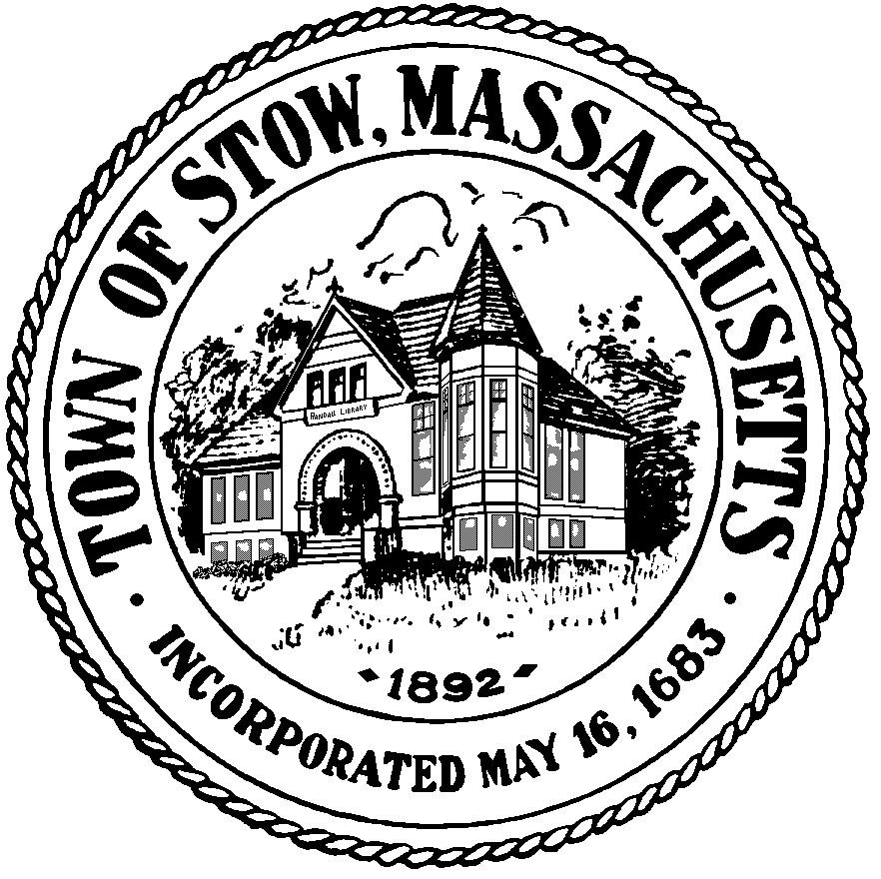

Town of Stow

community preservation committee

Agenda for Monday, August 22, 2011 7:30pm, Town Building
BILLS & MINUTES
STOW CONSERVATION TRUST: Update on conservation restriction on Maple Street
RANDALL LIBRARY TRUSTEES: Discussion about potential Library Restoration Project
STONE APPLE BARN PROPOSAL/DISCUSSION: Lew Halprin
SPECIAL TOWN MEETING: Discussion about warrant articles (if necessary)
NEWS AND VIEWS
UPDATES ON CURRENT PROJECTS
NEW BUSINESS

